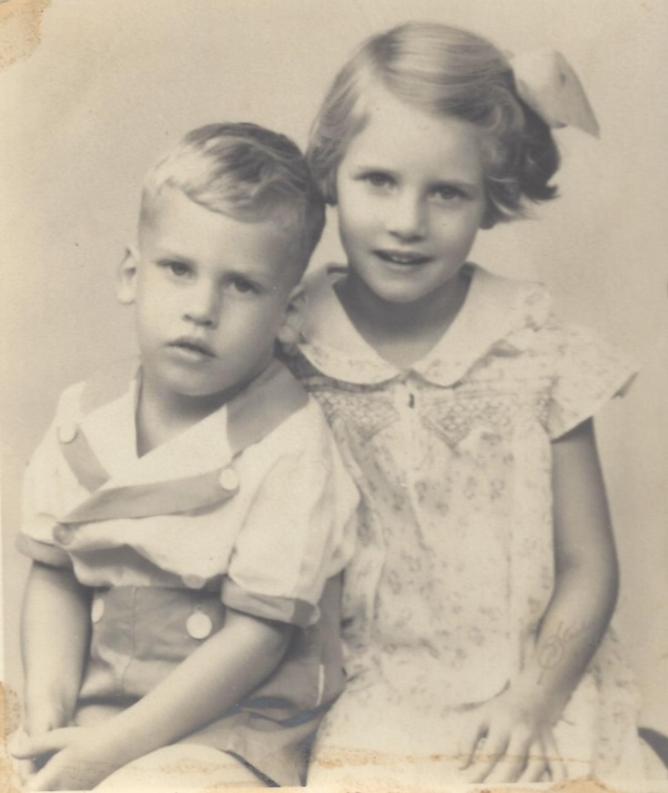

Russell Philip Wolfe and his sister, Lois Anne Wolfe – 1936

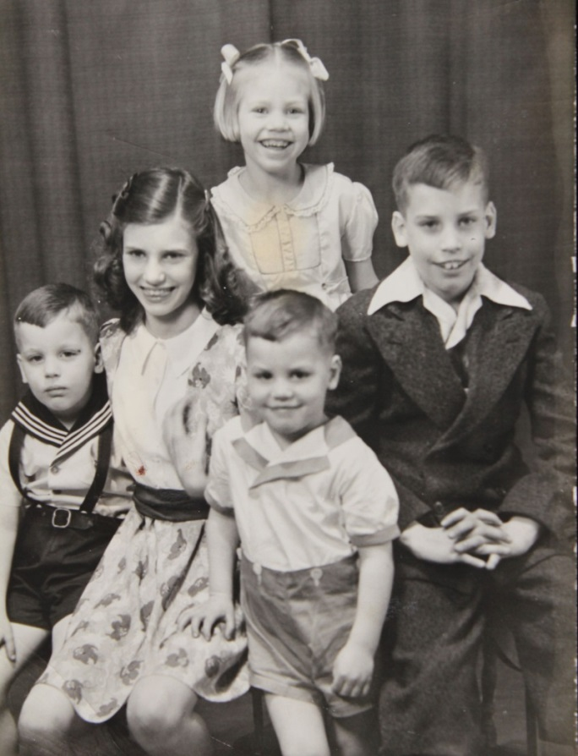

(l-r) Mary Helen Foster and Russell F. Wolfe children

Nelson, Lois, Mary Jo, John, Philip Wolfe – 1943